**PEMIKIRAN KRITIS DAN KREATIF**

**BIPW 3112**

**SEM 2 2021/2022**

**MODEL LOGIK**

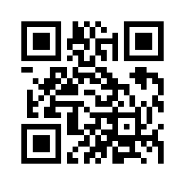

Arahan Model Logik

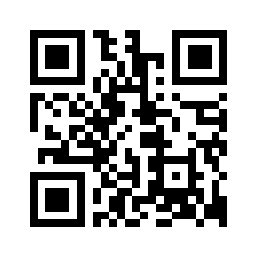

Nota Model Logik

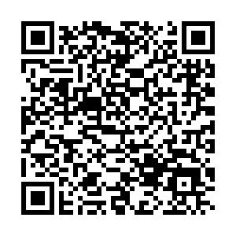

URL Model Logik

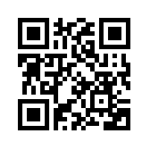

Video Model Logik 1

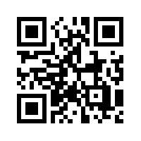

Video Model Logik 2

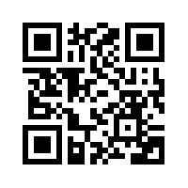

Video Model Logik 3